Active Safe Driving Assistant Terminal AI100

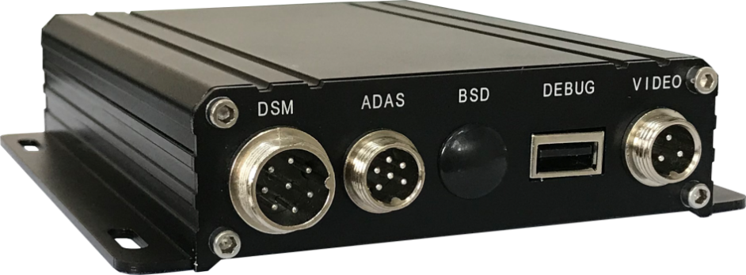
Features：
- ADAS supports LDW (Lane Departure Warning) / FPW (Front Vehicle Approach Warning) / FCW (Forward Collision Warning) and other warning functions
- DSM supports Fatigue (Yawning) / Looking around / Smoking / Phone Call / Covering/ Infrared blocking / Driver abnormal and other warning functions
- DSM camera supports four modes of installation: left rudder, right rudder, center control, and rearview mirror
- It can support for USB link Android debugging
- It supports multi-voice broadcast, voice file flexible replacement, no country and language restrictions
- It is suitable for many product models, and it supports Tongli full series with IPC network port equipment
- It combines local alarm and background remote monitoring functions, which can provide security services for drivers, passengers, operating units and regulatory departments. It can effectively avoid the occurrence of dangerous situations
- Professional on-board power supply set 8-32V dc wide voltage input design

Product Parameters:
Item | Name | Parameter
Mainframe | CPU | 4x1GHz Embedded processor
 | RAM | 512MB DDR3
DSM Camera | Resolution | 960H
 | Fps | 25fps
ADAS Camera | Resolution | 1280*720
 | FPS | 25fps
Alarm Picture and Video | Alarm picture | Format：JPG
 | Alarm video | H.264, Format:mp4
 | CVBS output | Multiple channel output,ADAS、DSM、BSD video
Working Voltage | DC wide voltage | DC 8-32V
Temperature Range | Temperature range | -20°～+70°
Product Size | Size（mm） | 133.6*102.8*33

Mainframe and interface：
Front Board：
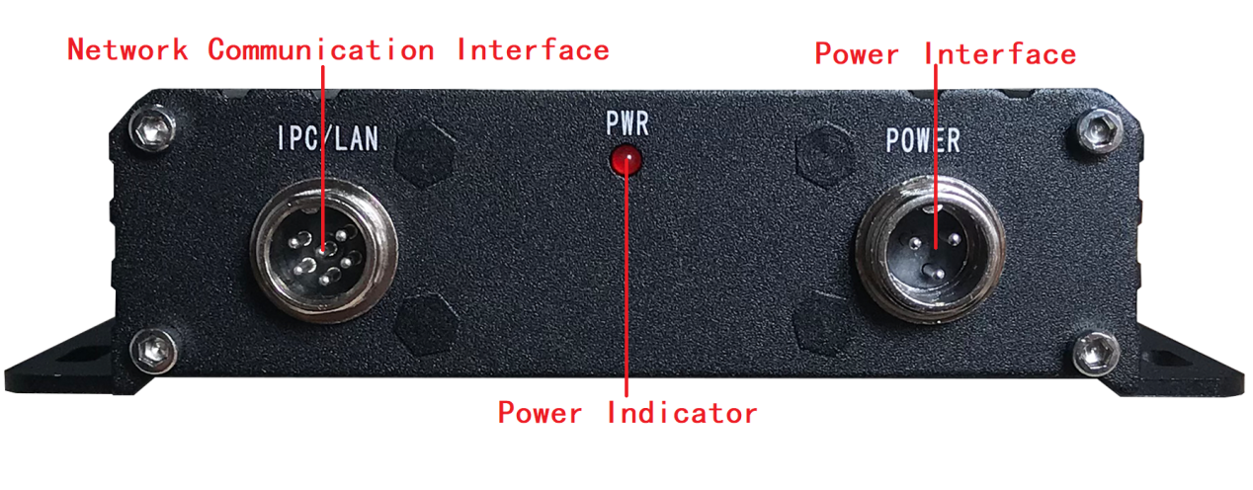
Back Board：
