4CH 1080P SD Card Mobile DVR MR9504EC

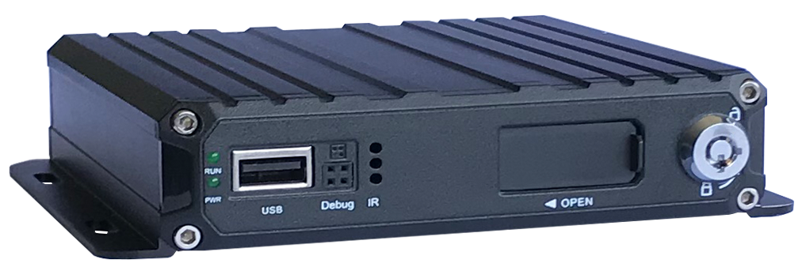

FEATURES:

- Built-in high performance Hisilicon chipsets, coded with H.264/H.265 standard, high compression rate and image quality
- AHD/TVI/CVI/ANALOG four in one video input, wide compliance
- Support 4 channel 1080P real-time preview and storage
- 1 channel of video and audio synchronous output
- VGA + CVBS output as standard
- Support UPS power input
- Reverse Assistance
- Adjust the camera image horizontally and vertically
- Adjust the camera image 90 degree rotation
Power:
- Professional In-Vehicle power design,8-36V DC Wide Voltage Range
- Multiple protection circuits like under-voltage, short, reversed plug-in
- Smart power management system, shutdown under low voltage, low consumption when standby
Storage：
- Built-in super capacitor to avoid data loss and disk damage caused by sudden outage
- Special file management system to encrypt and protect the data
- Proprietary technology to detect the bad track of the disk which can make sure the continuity of video and long service life of the disk
- Support SD card storage, maximum 1 x 256GB
Transmission Interface：
- Support GPS/BD optional, high sensitivity, fast positioning

Technical parameter:
Item | Device Parameter | Performance
System | Main Processor | Hi3520DV400
 | Operating System | Embedded Linux OS
 | Operating Language | Chinese/English/Russian
 | Operating Interface | GUI, Support mouse
 | Password Security | Two Layer password Admin/User
Audio  &  Video | Video standard | PAL/NTSC
 | Video compression | H.264/H.265
 | Image resolution | 1080P/ 720P /960H/D1/CIF
 | Playback quality | 1080P/ 720P /960H/D1/CIF
 | Decoding ability | 1ch 1080P real time
 | Recording quality | Class 1-6 optional
 | Image display | Single/Two/T/H/QUAD display optional
 | Audio Compression | G.726/ MG726/ G.711
 | Audio recording | Audio & Video synchronized recording
Recording & Playback | Recording mode | Manual/Alarm
 | Video bit rate | Full frame 4096Mbps，6 classes image quality optional
 | Audio bit rate | 8KB/s
 | Storage media | SD card
 | Video inquiry | Inquiry by channel/Recording type/Alarm Type
 | Local playback | Playback by channel, time
Firmware upgrading | Upgrading mode | Manual/Automatical/Emergency Recovery
 | Upgrading method | USB disk
Interface | AV input | 4ch 4pin aviation
 | AV output | 1ch VGA video output, 1ch aviation AV output
 | Alarm input | 4 digital inputs (4 Positive/Negative trigger)
 | SD card | 1 SDXC High speed card (1 x 256GB)
 | USB interface | 1 USB 2.0 (support U disk/mouse)
 | Ignition input | 1 ACC signal
 | LED Indication | PWR/RUN
 | Disk lock | 1个
 | Debug port | 1个
Function Extension | GPS/BD | Support detecting antenna Plug in/Unplug/Short circuit
Others | Power input | DC：8V~36V
 | Power consumption | Standby：5.8mA Maximum consumption：980mA
 | Working temperature | -20 --- 70℃
 | Storage Size | H.265 1080P 675M/hour/channel
 | Dimension | 142*153*33（mm）

