4ch AHD DUAL SD MOBILE DVR MR9604

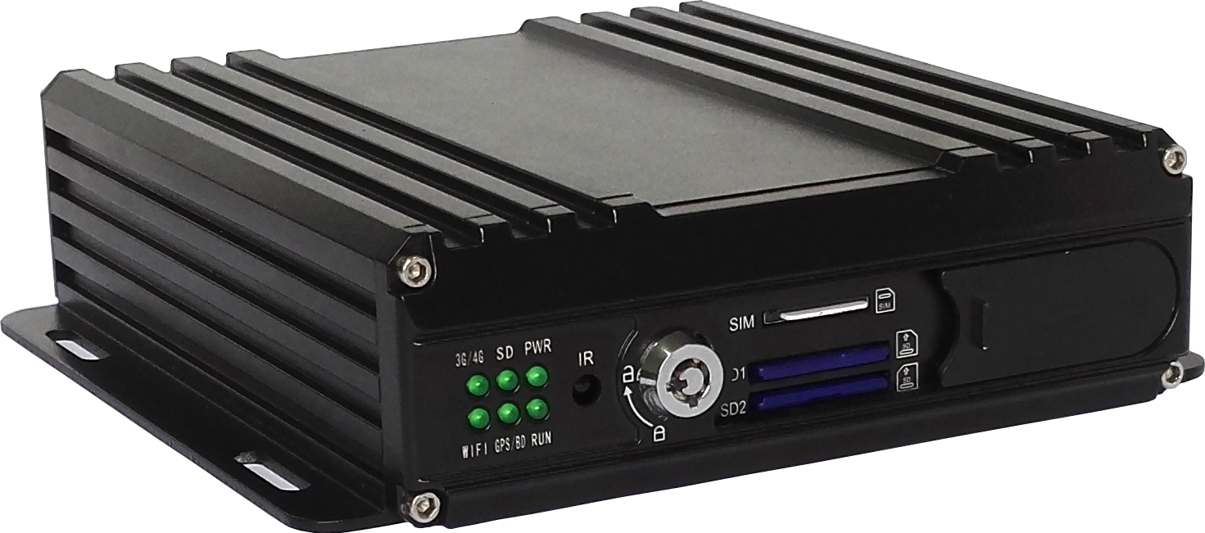

FEATURES:

- Built-in high performance Hisilicon chipsets, coded with H.264 standard, high compression rate and image qulity
- 4CH AV Inputs with AHD 720P/960H/D1/CIF optional, 1CH synchronized AV output, 1CH VGA output
- 4CH local recording with 720P resolution in real time
Power:
- Professional In-Vehicle power design, 9-36V DC Wide Voltage Range
- Multi protection circuits like under-voltage, short, reversed plug-in
- Smart power management system, shutdown under low voltage, low consumption when standby
- Support 5V DC power output for cameras, LCD monitor etc
Data Storage:
- Special file management system to encrypt and protect the data
- Proprietary technology to detect the bad track of the SD card which can make sure the continuity of video and long service life of the SD card
- Built-in ultracapacitor, avoid data loss and sd card damage caused by sudden outage
- Support dual SD card storage, maximum 256G each
- With M.2 interface for built-in SSD, maximum 256G
Transmission Interface:
- Support 3G/4G transmission, LTE/HSUPA/HSDPA/WCDMA/EVDO/TD-SCDMA
- Support GPS/BD optional, high sensitivity, fast positioning
- Support wireless download by WiFi, 802.11b/g/n, 2.4GHz
- Built-in G-sensor to detect the driver’s driving habits

Technical parameter:
Item | Device parameter | Performance
System | Main processor | Hi3520DV200
System | Operating system | Embedded Linux OS
System | Operating language | Chinese/English
System | Operating interface | GUI, support mouse
System | Password security | User password/Admin password
Video | Video standard | PAL/NTSC
Video | Video compression | H.264（Main Profile）
Video | Image resolution | 720P /960H/D1/CIF
Video | Playback quality | 720P /960H/D1/CIF
Video | Compound mode | 4ch 720P/4ch 960H/2ch 720P+2ch 960H
Video | Decoding ability | 1ch 720P real time
Video | Video input | 4ch video input, aviation interface
Video | Video output | 2ch video output (1ch video output, 1ch VGA)
Video | Recording quality | Class 1-6 optional
Video | Image display | Single/QUAD display optional
Audio | Audio compression | G.726
Audio | Audio input | 4ch audio input, aviation interface
Audio | Audio output | 1ch audio output, aviation interface
Audio | Audio recording | Audio & Video synchronized recording
Recording & Playback | Recording mode | Manual/Alarm
Recording & Playback | Video bit rate | Full frame 4096Mbps，6 classes image quality optional
Recording & Playback | Audio bit rate | 8KB/s
Recording & Playback | Storage media | 2 SD card and 1 SSD with M.2 interface
Recording & Playback | Video inquiry | Inquiry by channel/recording type
Recording & Playback | Local playback | Playback by file
Firmware upgrading | Upgrading mode | Manual/Automatical/Remote
Firmware upgrading | Upgrading method | USB disk/Wireless network
Interface | Video input | 4ch aviation interface
Interface | Video output | 1ch aviation interface, 1ch VGA
Interface | Audio input | 4ch aviation interface
Interface | Audio output | 1ch aviation interface
Interface | Alarm input | 4 digital inputs (2 positive trigger, 2 negative trigger)
Interface | Alarm output | 1 output (currenct<150mA, with built-in resettable over-current protector)
Interface | SD card | 2 SDXC high speed card (up to 256G each)
Interface | SSD interface | With M.2 interface for built-in SSD (up to 256G)
Interface | USB interface | 1 USB 2.0 (support U disk/mouse)
Interface | Ignition input | 1 ACC signal
Interface | RS232 interface | 2* RS232
Interface | IR interface | 1 built-in IR receiver
Interface | LED indication | PWR/RUN/DISK/CELL/WIFI/GPS
Interface | SD card lock | 1
Interface | Debug port | 1
Function extension | GPS | Support detecting antenna plug in/Unplug/Short circuit
Function extension | 3G/4G | LTE/HSUPA/HSDPA/WCDMA/EVDO/TD-SCDMA
Function extension | WIFI | 802.11b/g/n, 2.4GHz
Function extension | G-SENSOR | Support motion detecting  Support driving habits detecting (heavy acceleration/hard braking/sharp turns/crash)
Others | Power input | 9~36V DC（ISO7637 P5A 200V）
Others | Power output | 5V 300mA
Others | Power consumption | Standby 3mA  Maximum consumption 18W @12V 1.5A @24V 0.75A
Others | Working temperature | -20---70℃
Others | Storage | 720P 1G/h/channel  960H 750M/h/channel
Others | Dimension | 165*142*45 mm

Front Panel:
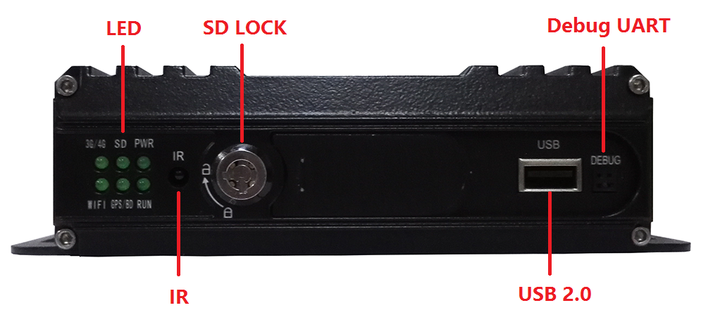
Back Panel:


