AHD MOBILE DVR
User Manual
(MR9704C)

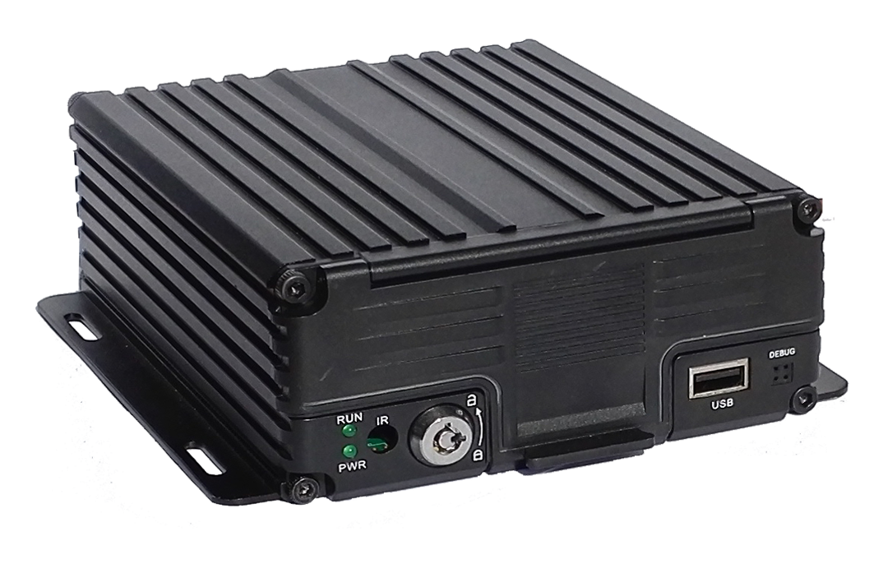

Catalogue
Chapter 1 Overview 1
Chapter 2 Quick setup 1
1．Device Installation 1
2. User Login 1
3．Set up the System time 2
4．Set up cameras 2
5．Wizard 3
5.1 Vehicle Information setup 3
5.2 DiskManagement 4
5.3 3G/4G Setup 4
5.4 WIFI Setting 4
5.5 Server setting 5
5.6 NetState 5
Chapter 3 System Menu 6
1.1 Video Playback 6
1.2 Video Backup 6
2．Basic Setting 7
2.1 Date Time setting 7
2.2 Vehicle Information 8
2.3 Preview setting 8
2.4 Video Output 9
2.5 On/Off setting 9
2.6 System setup 10
2.7 System Information 10
3．Network setup 11
3.1 Server setup 11
3.2 3G/4G Setup 11
3.3 WIFI setting 12
3.4 Network State 13
4．Recording Setup 13
4.1 Recording Mode setting 14
4.2 Main Stream 14
4.3 Sub Stream 15
4.4 Recording storage 15
4.5 Recording OSD (On Screen Display) 15
4.6 Image setting 16
4.7 Mirror setting 16
5．Advanced setting 16
5.1 User Management 17
5.2 Driving Habits monitoring 17
5.3 UART setting 17
5.3.1 UART-TTS 18
5.3.2 UART-Serial Net (Pass Through) 18
5.4 Reverse Camera 18
5.5 NetTextShow 19
6．Device Maintenance 20
6.1 Log Inquiry 20
6.2 Disk Management 21
6.3 Related with the Parameter 21
6.4 System upgrading 21
7．Alarm setting 22
7.1 Input Alarm 22
7.2 AlarmOut setting 23
7.3 Video Loss 24
7.4 Fatigue Driving Alarm 24
7.5 OverSpeedAlarm 25
7.6 DiskError 25
Chapter 4 Installation Warnings 26

Chapter 1 Overview
MR9704C is a DVR designed for Analog HD vehicle monitoring. With built-in high performance image processor and advanced H.264 video compression technology, it provides AHD video recording, storage and playback solution. It has built-in 3G/4G/WiFi module (optional) for remote monitoring, analysis and management. It comes with smart power management system which can recognize the power type automatically. When detected the battery’s voltage is lower than the gaven value, the device will shutdown automatically and keep ultralow standby consumption.

Chapter 2 Quick setup

1．Device Installation
Please refer to “AHD MOBILE DVR Hardware User Manual (MR9704)” for the hard disk installation and cables connection.

2. User Login
Right click the mouse, you will call out the login interface, please input your UserName, Password, and select your language, click “OK” to login the menu. (The default UserName is admin, without Password), see as following:
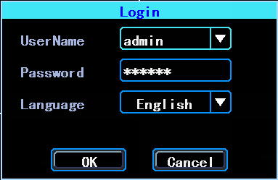
User Login Interface

Right click the mouse, select “Menu” to start setup in the menu, see as following:
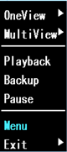
- System Menu
“Menu” is the primary menu of the system setup and control, see as following:
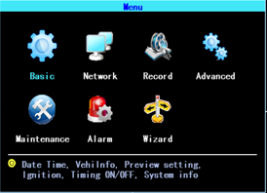

- Primary Menu

3．Set up the System time
Path: Basic->DateTime, see as following:

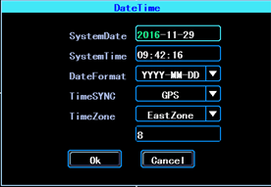
- System date and time
TimeSYNC: Date and Time can be synchronized with GPS/BD

4．Set up cameras
Path: Menu->Record->Mode. Please set up your cameras’ SignalType, Valid/Invalid. The DVR works with both AHD and general cameras. If you use AHD cameras, please select the first Type, if you use general cameras, please select the third Type, if you use both of general and AHD cameras, please select the second Type. See as following:

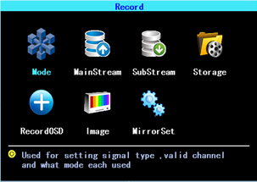
- Recording setting

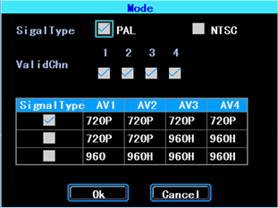
- SignalType setup
PS: If your cameras don’t display image on the monitor, please check this setup.

5．Wizard
Path: Menu->Wizard. This Wizard will help you to quick set up the device connect with the server.

5.1 Vehicle Information setup
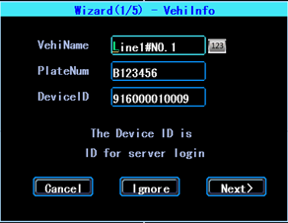
- Vehicle information setup
The DVR is using “Device ID” to connect with the server, so please input the correct DeviceID which was registered on the server for your device. The user can modify the VehicleName and PlateNumber according to their requirement. The PlateNumber is the vehicle’s plate number, and it will be displayed in the video.

5.2 DiskManagement
Disk need to be formated in the device when using it for the first time. If the disk was not detected by the device, please check the disk lock and make sure it is well locked

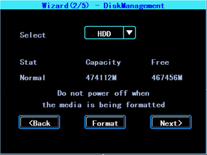
- Wizard-DiskManagement

5.3 3G/4G Setup
The device will detect the 3G/4G ModuleType automatically. Please insert the right SIM card which corresponding with the ModuleType detected. Please consult your SIM card carrier or search on internet to make sure you put the correct parameters (DialNumber, APN, UserName, Password). If you use VPN, please consult your telecom carrier to get the correct parameters.
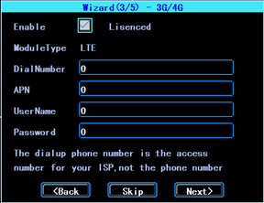
- 3G/4G setting

5.4 WIFI Setting
The device can save maximum 6 WiFi ESSID (Access Points). It will search, match, connect, and switch automatically. Click the corresponding blank to start WiFi setup. Then click “Search” you will see the available WiFi around your area, select the one your want to connect and input the password and save it.

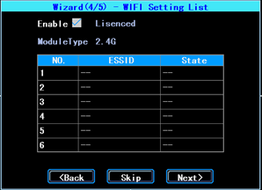
- WIFI setting list

5.5 Server setting
IP (or Domain) is your server’s IP (or Domain), the Port should be same with your server setup.

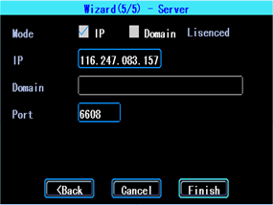
- Wizard-Server setting

5.6 NetState
Path: Menu->Network->NetState. You can check the state of the network connection of your device here.
Server: Online, it means the device connected with the server.

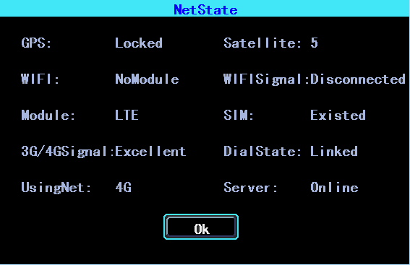
- NetState

Chapter 3 System Menu
- System menu

1.1 Video Playback
The device supports one channel video playback, Select “Playback” in the System menu, then you will get the video searching interface, please search the video according to your requirement.
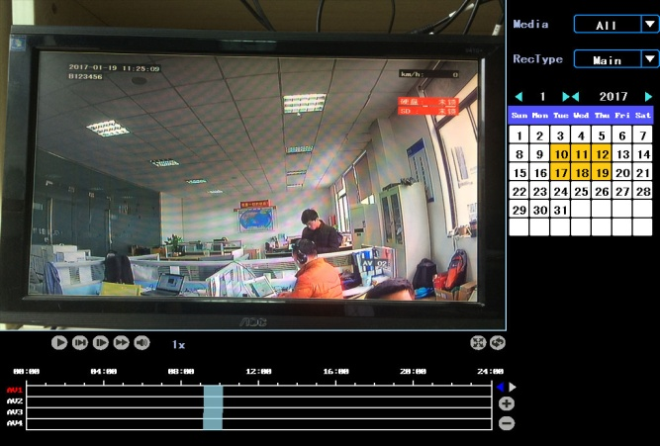
- Video searching
The days in yellow are with recorded video. The blue parts in the time line bar are with recorded video. Please move the cursor of your mouse at the corresponding channel and time, and then left click it to replay the video.

1.2 Video Backup
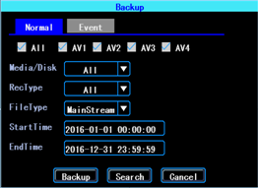
- Video Backup
You can backup the video with an USB drive. There are two backup modes: “Normal backup” and “Event backup”

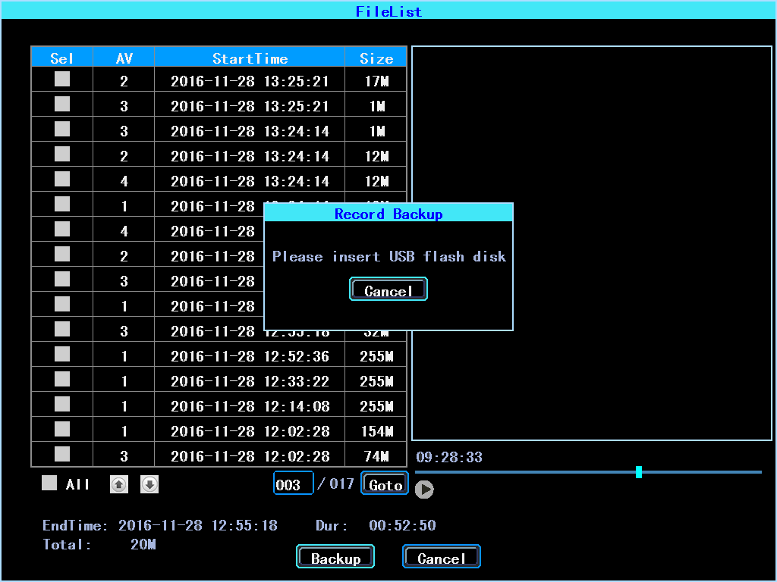
- Video file list
Select the video file which you want to backup and then click “Backup”, remove your mouse and insert your USB drive, then the backup will start.

2．Basic Setting
The basic setup includes the very basic setup items such as DateTime, Vehicle Information, and Preview etc., See as following:
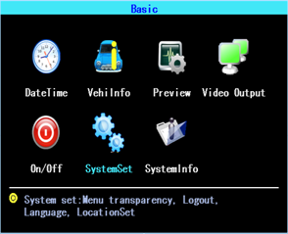
- Basic setting

2.1 Date Time setting
- Date Time setting
Time synchronization: The system's date and time can be synchronized with GPS/BD.
  - Vehicle Information
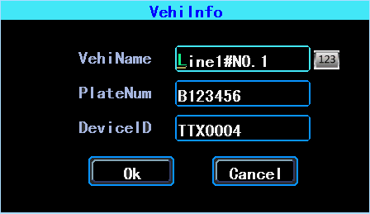
- Vehicle Information
Device ID: It is the ID used to connect your device with the server. It should be the same ID which you registered your device on the server.

2.3 Preview setting
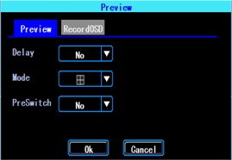
- Preview setting
OSD: On Screen Display. You can select some information to display on the preview screen (the displayed information is for preview, not for recording)
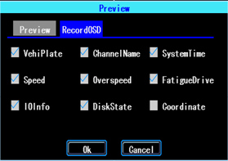
- Preview OSD

2.4 Video Output

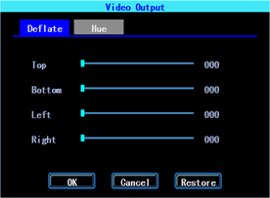
- Video Output

2.5 On/Off setting
On/Off “Ctrl” setting is for starting on and shutting down the device automatically WHEN THE DEVICE IS ON STANDBY AFTER ACC IGNITION OFF. You can set up three time segments.
ACC Delay: You can set up the device to keep working for a gaven time period after the vehicle ACC ignition off.

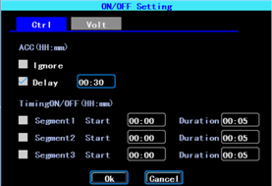
- On/Off Control setting

The On/Off “Volt” setting is for setting the voltage to shut down and start on the device, this feature can avoid the device drained the vehicle’s battery.
The device will detect the current voltage automatically, when the vehicle’s battery voltage is lower than the Shut.Volt, the device will shut down automatically to avoid drained the battery. When the voltage is higher than the PowerVolt, the device can be startted on.
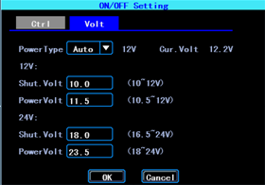
- On/Off Voltage setting

2.6 System setup
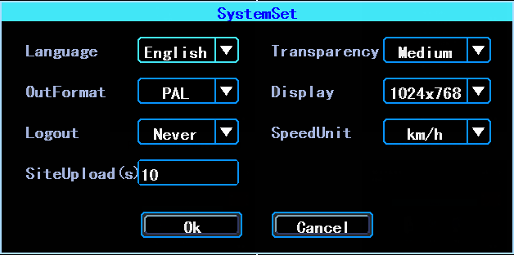
- System Setup

2.7 System Information
System information includes: Device Model, Serial Number, Hardware & Firmware version etc.
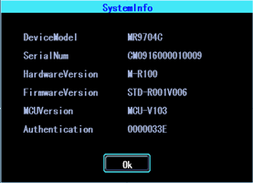
- System Information

3．Network setup
Network setup: This interface is used to set up the necessary parameters to connect the device with the server
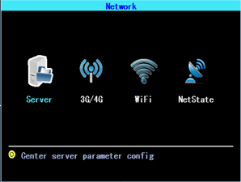
- Network Setup

3.1 Server setup
IP/Domain is the WAN static ip or domain of your device’s server.
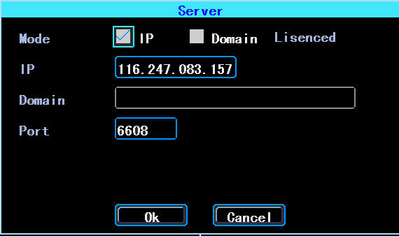
- Server setup

3.2 3G/4G Setup
The device will detect the 3G/4G ModuleType automatically. Please insert the right SIM card which corresponding with the ModuleType detected. Please consult your SIM card carrier or search on internet to make sure you put the correct parameters (DialNumber, APN, UserName, Password). If you use VPN, please consult your telecom carrier to get the correct parameters.
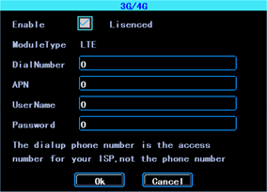
- 3G/4G setup

3.3 WIFI setting
The device can save maximum 6 WiFi ESSID (Access Points). It will search, match, connect, and switch automatically. Click the corresponding blank to start WiFi setup. Then click “Search” you will see the available WiFi around your area, select the one your want to connect and input the password and save it.
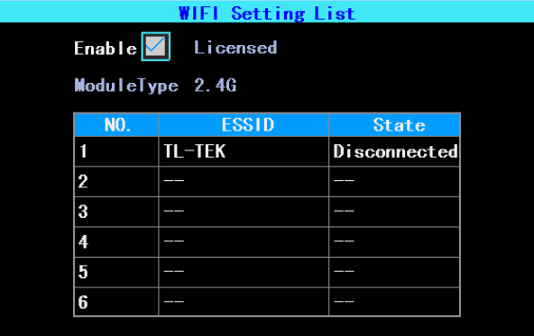
- WIFI Setting List
You can input the ESSID of the WiFi AP but you can also click “Search” to search the available WiFi ESSIDs around your area.

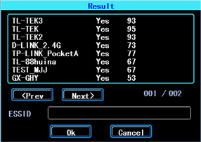
- WIFI Searching result

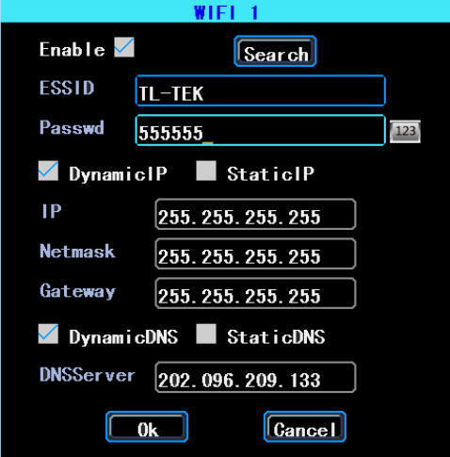
- WIFI setting
Input the password and select the IP type and then click “OK”

3.4 Network State
You can check the state of the network connection of your device here. Server “Online” means the device connected with the server succesfully.
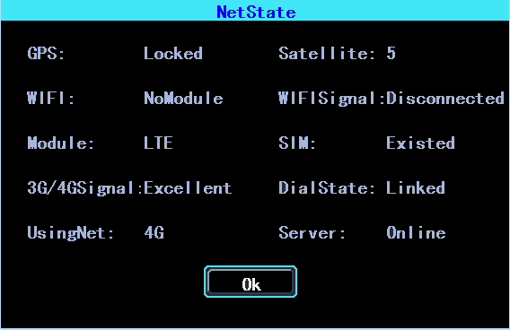
- Network State

4．Recording Setup
Recording setup includes Mode, Main Stream, Sub Stream, Recording OSD, Image, Mirror recording setting.
- Recording setting

4.1 Recording Mode setting

- Recording Mode setting

Please set up your cameras’ SignalType, Valid/Invalid. The DVR works with both AHD and general cameras. If you use AHD cameras, please select the first Type, if you use general cameras, please select the third Type, if you use both of general and AHD cameras, please select the second Type.

4.2 Main Stream
Main Stream will be stored in local disk. This interface shows the current Main Stream setting and the corresponding storage size, you can click any line to set up the corresponding parameters.
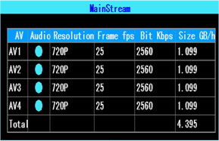
- Main Stream List
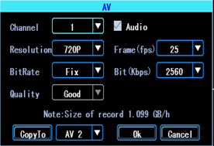
- Main Stream AV setting
Bit is adjustable between 1024Kbps-4096Kbps (6 classes image quality).

4.3 Sub Stream
SubStream is used for network transmission and backup in local disk
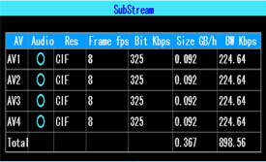
- Sub Stream setting
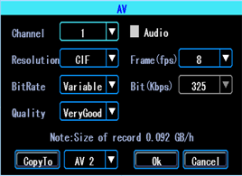
- SubStream AV setting
If you use 4G network, you can set up the resolution to be D1, so you can get better effect when you viewing the live video remotely on PC or cell phone.

4.4 Recording storage
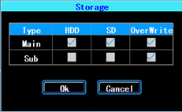
- Recording storage
The device supports dual storage (or you can say “Mirror storage), means you can store the same recording in both HDD and SD at same time. For example, you can store the main stream in HDD and sub stream in SD card, when the HDD has error and doesn’t work, you can still get backup video from the SD card (sub stream).

4.5 Recording OSD (On Screen Display)
You can set up the information you want to be recorded in the video.

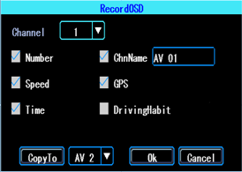
- Recording OSD

4.6 Image setting
Image setup is used to adjust to camera’s image effect, please set up it carefully.

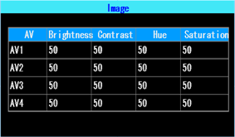
- Image setup

4.7 Mirror setting
This feature can turn over the camera’s image horizontally or verticaly (for both preview and recording)
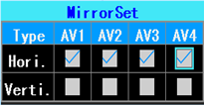
- Mirror setting
- Advanced setting
This interface is used for UserManagement, Driving Habits monitoring, UART port setting, Temperature Sensor, Reverse Lines setting, displaying the text received from the server.
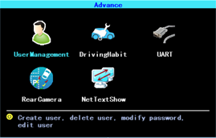
- Advanced setting

5.1 User Management
You can add, modify, delete users, and modify the login username and privileges.

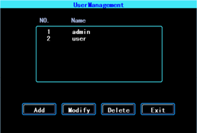
- User Management

5.2 Driving Habits monitoring
(this feature is under developing)

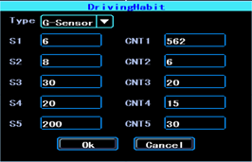
- Driving Habits monitoring

5.3 UART setting
This device has 1 UART port (TTL). You can connect some peripheral devices such as TTS (Text To Speech), Network Pass Through etc with the DVR vai our UART convertor.
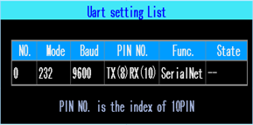
- UART setting list

5.3.1 UART-TTS
Select UART to get into UART setting interface.
Select “TTS” in the drop-down box of “Function”. Config the parameters as per the picture followed:

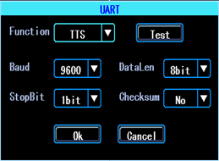
- UART setting

5.3.2 UART-Serial Net (Pass Through)
Select UART to get into UART setting interface.
Select “SerialNet”（PassThrough）in the drop-down box of “Function”. Config the parameters as per the picture followed:
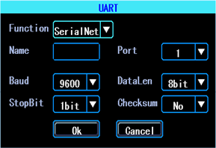
- UART setting

5.4 Reverse Camera
The DVR comes with Reverse camera function. Any channel can be used as reverse camera, click “Zone” to set up the reverse assistance lines.
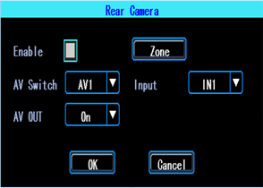
- Reverse camera setting
PS: Normally we will select “On” at “AV OUT”. If you select “Off”, the screen will sleep when there is no operation for a while.

The assistance lines are adjustable (dragging the blue points)

- Assistance lines setting

5.5 NetTextShow
The device can display and broadcast the text received from the server. (If you want broadcast the text, you need to connect TTS device with the DVR.)
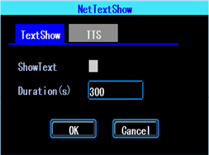
- NetTextShow
You can set up the display time duration of the text.
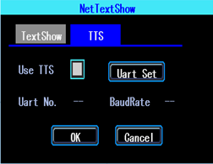
- TTS broadcasting
If you waant to broadcast the text received by TTS device, please click “Uart Set” to set up it first.

6．Device Maintenance
设“Device Maintenance” includes the basic maintenance of the device such as Log searcing, Disk Management, Config parameter import/export, System Upgrading.
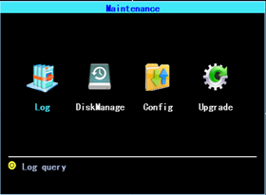
- Device Maintenance.

6.1 Log Inquiry
Inquiry the system’s running log according to the required Log Type and Time Range.

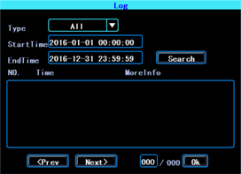
- Log inquiry
The log will record the device’s exception, local operation, system on/off, alarm information etc.

6.2 Disk Management
You can check the status of the disk here.
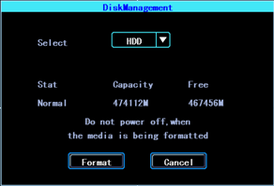
- Disk Management
The disk need to be formatted in the device when you use it for the first time.

6.3 Related with the Parameter
Import/Export is used to import/export the setup and config information for setup in batch.
After setted up one device, export the setup parameters with your USB disk, then insert the USB disk into other device’s USB port and re-power on the device, it will get the setup parameters utomatically. (If you don’t want to re-power on the device, you can import the setup paramaters in menu, see as followed)

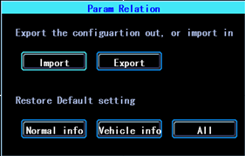
- Import/Export
PLEASE USE THE RESTORE FUNCTION CAREFULLY TO AVOID THE LOST OF YOUR IMPORTANT DATA

6.4 System upgrading
Please format your USB disk as FAT32 type and copy the upgrading file to the root directory of the USB disk. Then re-power on the device, it will upgrade automatically. If you don’t want to re-power on the device, you can upgrade it in the menu “Import/Export”. Select the upgrading type, click OK, then insert the USB disk. The system will detect the USB disk and the file and then upgrade automatically.
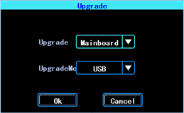
- System upgrading

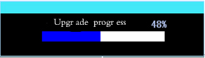
Upgrading progress
PS: You can insert the USB disk which with the upgrading file, and then re-power on the device, it will upgrade automatically. You can also upgrade the device remotely from PC CMS software if your device has 3G/4G or WiFi function.

7．Alarm setting
Alarm setup interface includes the setting related to all alarm types, such as I/O alarm, Video Loss, Fatigue Driving, Over Speed, Disk error.
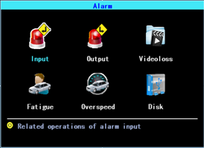
- Alarm setting

7.1 Input Alarm
The device has 4 alarm inputs, 2, 4 are positive trigger, 1, 3 are positive/negative trigger (optional)
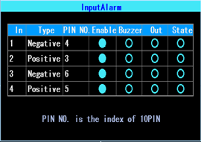
- Input Alarm list
Click the corresponding lines to setup
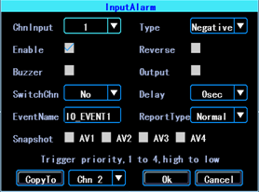
- Input Alarm setting
There are three input modes: high level, low level and open. For positive trigger, the normal trigger level is high, but if the reversed logic is enabled, the trigger level is changed to low level and open. It is same for negative trigger.

Alarm Input Trigger status list
Alarm Trigger |  | Positive trigger | Negative trigger
Reversed Logic | No | High level | Low level
Reversed Logic | Yes | Low level/Open | High level/Open

7.2 AlarmOut setting
You can set up the type of alarm output (interact, remote, manual), Manual is used to debug the device.

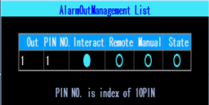
- AlarmOut Setting
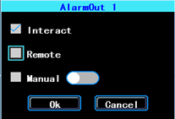
- Alarm Out Types

7.3 Video Loss
Video Loss alarm will be triggered if there is no camera or wrong type camera were connected with a valid channel.
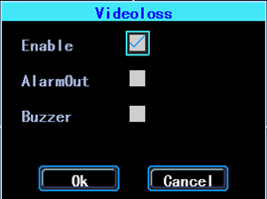
- Video Loss alarm setting

7.4 Fatigue Driving Alarm
The Fatigue Driving time is calculated since the device was started.
In this interface you can set up the fatigue driving time, to remind the driver to avoid fatigue driving.

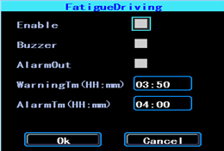
- Fatigue Driving setting

7.5 OverSpeedAlarm
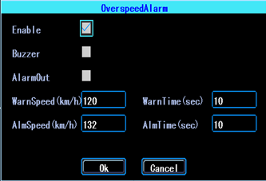
- OverSpeedAlarm Setting

7.6 DiskError
You can set up alarm when there is Disk Error detected by the device

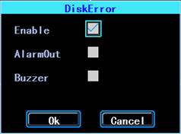
- Disk Error setting

Chapter 4 Installation Warnings
For safely using and long service life, please respect these Warnings when insalling and using the device:
1. When you received the product, please open the box and check the device and accessories. If there is anything damaged or missing, please contact your seller.

2. When installing and operating the device, please respect the standard of all electronics and the connecting requests of the vehicle and other devices

3. Please double check the input power voltage, it should be 8-36V DC, to avoid the damage caused by wrong voltage.

4. The device should work in the permitted temperature and humidity.

5. There should be enough space and fire resistant pipes on the external cables of the device to avoid electric leakage caused by abrasion and aging.

6. The installation and construction should be compliant with the standard of the government.

