8CH AHD HDD MOBILE DVR MR9708C

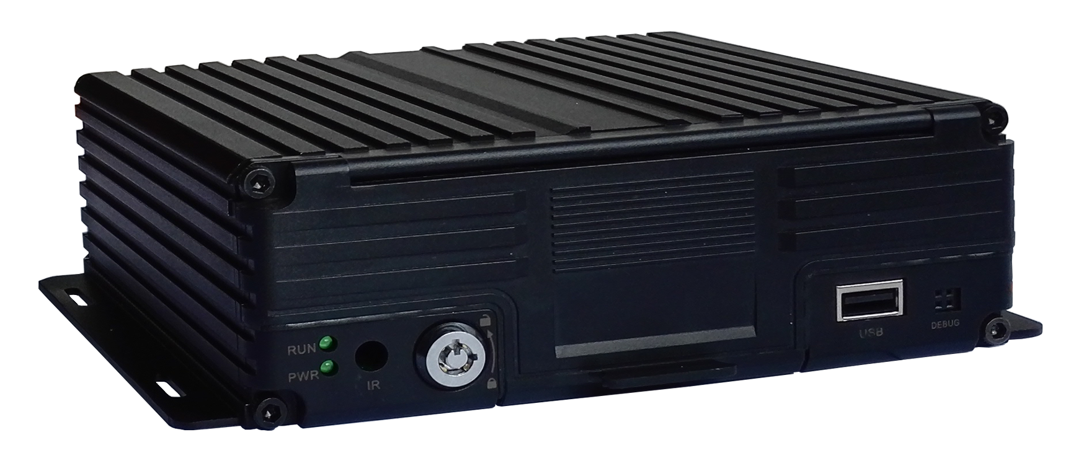

FEATURES:

Built-in high performance Hisilicon chipsets, coded with H.264 standard, high compression rate and image qulity
- 8CH AV Inputs with AHD 1080N/720P/960H/D1/CIF optional, 1CH synchronized AV output, 1CH VGA output
- 8CH local recording with 1080N resolution in real time
Power:
- Professional In-Vehicle power design,8-32V DC Wide Voltage Range
- Multi protection circuits like under-voltage, short, reversed plug-in
- Smart power management system, shutdown under low voltage, low consumption
Data Storage:
- Special file management system to encrypt and protect the data
- Proprietary technology to detect the bad track of the hard drive which can make sure the continuity of video and long service life of the hard drive
- Built-in ultracapacitor, avoid data loss and sd card damage caused by sudden outage
- Support 2.5 inch HDD/SSD, maximum 2TB
- Support SD card storage, maximum 256GB
- Support hard disk heating
Transmission Interface:
- Support 3G/4G transmission, LTE/HSUPA/HSDPA/WCDMA/EVDO/TD-SCDMA
- Support GPS/BD optional, high sensitivity, fast positioning
- Support wireless download by WiFi, 802.11b/g/n, 2.4GHz

Technical parameter:
Item | Device parameter | Performance
System | Main processor | Hi3520DV300
System | Operating system | Embedded Linux OS
System | Operating language | Chinese/English
System | Operating interface | GUI, support mouse
System | Password security | User password/Admin password
Audio  &  Video | Video standard | PAL/NTSC
Audio  &  Video | Video compression | H.264
Audio  &  Video | Image resolution | 1080N/720P/960H/D1/CIF
Audio  &  Video | Playback quality | 1080N/720P/960H/D1/CIF
Audio  &  Video | Compound mode | A variety of ways
Audio  &  Video | Decoding ability | 1ch 1080N real time
Audio  &  Video | Recording quality | Class 1-6 optional
Audio  &  Video | Image display | Single/QUAD display optional
Audio  &  Video | Audio Compression | G.726
Audio  &  Video | Audio recording | Audio & Video synchronized recording
Recording & Playback | Recording mode | Manual/Alarm
Recording & Playback | Video bit rate | Full frame 4096Mbps，6 classes image quality optional
Recording & Playback | Audio bit rate | 8KB/s
Recording & Playback | Storage media | SD card + HDD/SSD storage
Recording & Playback | Video inquiry | Inquiry by channel/Recording type
Recording & Playback | Local playback | Playback by file
Firmware upgrading | Upgrading mode | Manual/Automatical/Remote/Emergency Recovery
Firmware upgrading | Upgrading method | USB disk/Wireless network/SD card
Interface | AV input | 8ch aviation interface
Interface | AV output | 1ch VGA video output, 1ch aviation AV output
Interface | Alarm input | 4 digital inputs (4 Positive/Negative trigger)
Interface | HDD/SSD | 1 HDD/SSD (up to 2TB, support hot plug/unplug)
Interface | SD card | 1 SDXC High speed card (up to 256GB)
Interface | USB interface | 1 USB 2.0 (support U disk/mouse)
Interface | Ignition input | 1 ACC signal
Interface | UART | 1 LVTTL Level
Interface | LED Indication | PWR/RUN
Interface | Disk lock | 1
Interface | Debug port | 1
Function extention | GPS/BD | Support detecting antenna Plug in/Unplug/Short circuit
Function extention | 3G/4G | Supports CDMA/EVDO/GPRS/WCDMA/FDD LTE/TDD LTE
Function extention | WIFI | 802.11b/g/n, 2.4GHz
Others | Power input | 8~32V DC
Others | Power output | 5V 300mA
Others | Power consumption | Standby 3mA  Maximum consumption 30W @12V 2.5A @24V 1.25A
Others | Working temperature | -20 --- 70℃
Others | Storage | 1080N 1.2G/h/channel  720P 1G/h/channel  960H 750M/h/channel
Others | Dimension | 162mm*180mm*50.5mm

Front Panel:
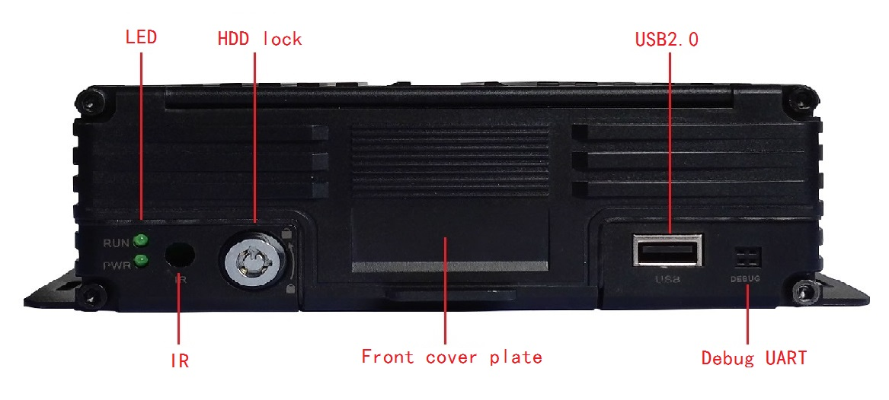
Back Panel:


